**User Manual of Automatic Entry Test Evaluation System**

**Generate Test:**

First of all open the “paper checker” folder , in this folder you would found EXE file with name of “Paper Checker.exe” where you have multiple options of

i)For generation of Answer sheet you have to click the button “Generate Test”

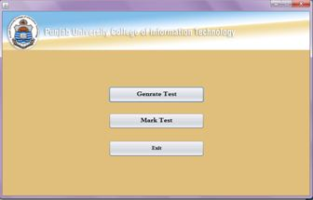

ii)In the field of total question write the digit how many questions(MCQs) you want to create on paper.

iii)Write your Test title for example “Computer Vision Quiz#01”

iv)”Destination path ”mean specify location where you want to place generated sheet

v)Give a roll number file(should be text File) in a format(.txt) and must be in given format

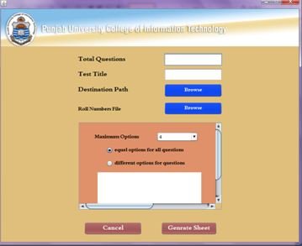

Generated number of sheets would be equal to number of roll numbers.

**Mark Test:**for test evaluation just click the button “Mark test”

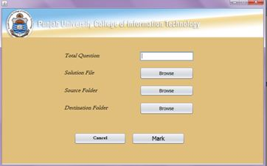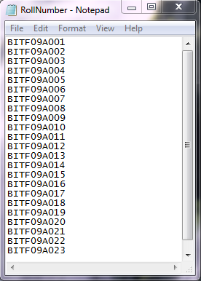

i)Specify number of questions that you want to check. Number of questions on Answer sheet would be equal to that you are specifying.

ii)Give a solution file but solution file would be equal to above mention format and this one also would be text file

iii)In source folder specify the location where you have Scanned Images(images would be in JPEG(.jpg) format)

iv) Specify the folder where you have to place Solution Files after checking

**Wait:** It takes may be more time just because of rotation and scaling in your images

After that a sheet would be appear in front of you and required four clicks from you.

i)1st click for start of your questions ii)2nd for horizontal distance iii) 3rd for second column

iv) 4th for vertical distance

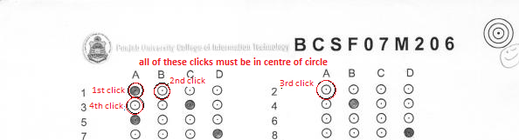

After every click system asked from you, you are sure that you click the center of the circle select “yes” and proceed.